Project Proposal

GEO Tracking
A GPS tracking solution



Development Team
Giannakopoulos G. (PM)
Papakonstantinou G.
Karanikas G.
Zikas G.

- Goal
The purpose of this project is to create a complete solution for handling GPS trackers and the produced locations. By accessing a web browser application, the clients will be able to get graphical information about their tracker's activity, such as current location and route, over a given period.

- Methodology
The following picture shows the topology of our application.

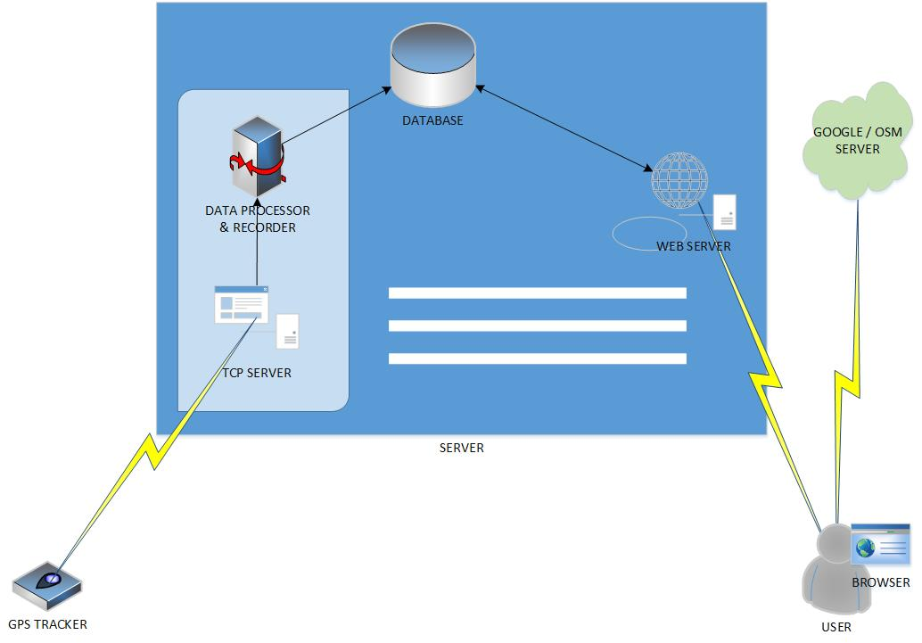

  - GPS tracker
Client owned device. Although this software is built in reference to TK-102B model, it will be adaptable with any tracker that communicates its data over TCP, with minimal (if any) changes.
  - TCP server
The role of the TCP server is to receive data from the tracker. After proper handling, it will be using them to populate the database's tables. It should provide efficient multiplexing.
  - Browser
Clients will have access to our software through a web application. Key feature will be representation of GPS data through Google Maps or OpenStreet.
  - Web server
It will host our web application. Content will be served through html/php forms. The web server is responsible for accepting and processing clients' requests, retrieving data from the database and serving them. Moreover, it should implement SSL and hardening against known application layer attacks, such as SQL injections, cross site scripting and cross site request forgery.
  - Database
Standard database implementation using MySQL.

- Schedule
Task deadlines are shown in the following chart.

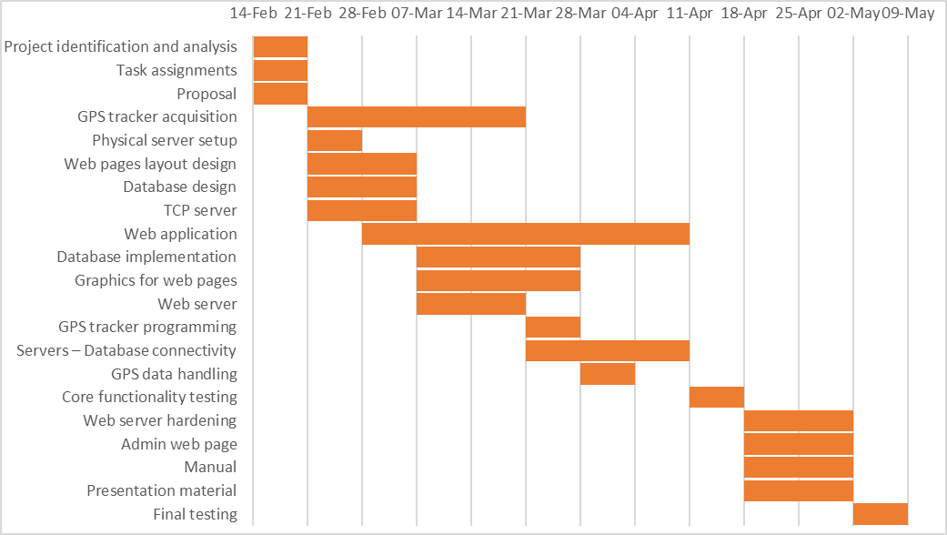

Tasks assignments are:

Giannakopoulos:
- TCP server
- Web server
- Database connectivity
- GPS data handling
- Web server hardening

Papakonstantinou:
- GPS tracker acquisition
- Physical server setup
- Browser application
- GPS tracker programming
- Admin web page

Karanikas:
- Database design
- Database implementation
- Manual

Zikas:
- Web pages layout design
- Graphics for web pages
- Presentation material

Moreover, the following tasks are to be performed by the whole team:
- Project identification and analysis
- Assignments
- Proposal
- Core functionality testing
- Final testing

- Risk assessment

- Market Analysis
Market expectations for this product are dependent mainly on necessity, availability and ease of use. For the former, the need for locating missing, high valued possessions, is already there. Whether it is yourself missing, a car, a luggage in an airport, or even an intractable employee, the ability to access remotely a GPS tracker is invaluable. Moreover, the client has the ability to check the tracker anywhere, anytime. No extra devices or software are required, only an internet connection. High availability of the service enables us to promote the product as a stable and consistent solution. Lastly, the front end of our application is simple, requiring no technical expertise, allowing us to target large consumer demographics.
aasssssssssstttechntechnical expertise, making it suitable for a large consumer demographic.

